Shepard Fairey Lab- adapted from Tim Chartier "Math Bytes" – **nice read**!

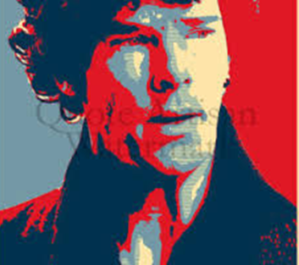

A lot of colors combine to form an image, whereas the Shepard Fairey uses only four. Fairey's collage groups portrait contains only off-white, red and two shades of blue. Fairey's collage groups large regions with a single color. The trick is determining which pixels to group. The darkest sections of the portrait use the darkest hue of Fairey's four color palette. We really only need to measure a pixel's intensity rather than its actual color. A pixel colored (255,0,0) could be viewed as having the same intensity as a pixel visualizing (0,255,0).

So in hope of "Fairey-fication" let's convert the image to grayscale by computing the average of each pixel's red, green, and blue values. If pixel is colored (r, g, b), then we replace this with the single value (r + g + b)/ 3 = gray value. Grayscale contains only one color channel ranging from black (value of 0) to white (value of 255).

**Two Sides of Shepard-fying**

We'll Shepard-fy a picture in two ways. Both algorithms begin by sorting a picture's grayscale values into ascending order. Then, each element in the sorted list is assigned one of the four colors in the Obama image. Finally the corresponding pixel is the original image is recolored with the assigned color from the sorted list. The methods differ in how such coloring is decided.

**Method one – a balanced approach.**  This method uses all four colors in equal amounts. This is easily done by dividing the sorted list of pixels values into four equally sized groups. The pixels in group 1,2,3 and 4 are colored dark blue, red, light blue and off-white respectively.

**Method two- an intense approach.** This method colors by intensity and generally won't use the colors in equal amounts. After the sorting, find the smallest and largest grayscale values in the image and call them s (small) and b (big). Then, divide the interval between s and b into 4 equally spaced subintervals. Therefore, every pixel in the image has a value greater or equal to s and less than

(b-s)/4 is in group 1. Note , we don't know how may pixels this will be. The other groups are formed in a similar way. Then, as before, the pixels in group 1,2,3 and 4 are colored dark blue, red, light blue and off-white, respectively.

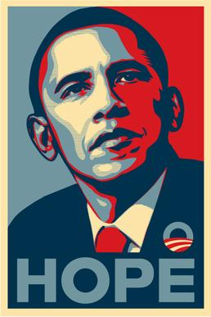

Take your picture and run it thru both of your methods to see the result.

**Method three – a different set of colors**. Choose your own 4 color palette (dark brown, tan, green, yellow) and convert your picture. This link may help you choose a different 4 color pallet.

<http://paletton.com/#uid=71T1p0kllll1FEsbvsfvberW17x>

Turn in a Folder (FirstLastPictureLab) with: 3 picture and source code.

After you change your picture can you extend & add or just add a word to the bottom (using Paint makes this easy)?

I will show you how to write and save your picture.